1300 Peachtree Industrial Blvd Suite 4101 Suwanee, Ga 30024
Phone: (770) 831-5525
Fax: (770) 831-5527
www.GwinnettUrgentCare.com

Workers Compensation Registration Form
Worker Information
Patient Name | Date of Birth
Date of Injury | Social Security Number

Employer Information
Employer Name | Employer Contact/Supervisor Name
Employer Phone Number | Employer Contact/Supervisor Phone Number
Employer Address | Employer Contact/Supervisor Email

Workers Compensation Insurance Information
Insurance Company Name | Insurance Company Address
Insurance Company Phone Number | Insurance Company Fax Number
Policy Number | Drug Testing Required? (circle one)  5-panel in-house 5-panel send to lab  10-panel send to lab DOT drug screen None
Claim Number | Special Instructions?

1300 Peachtree Industrial Blvd Suite 4101
Suwanee, Ga 30024
(770) 831-5525
Hours of Operation:
Monday-Friday 8:00am-8:00pm Weekends 10:00am-6:00pm
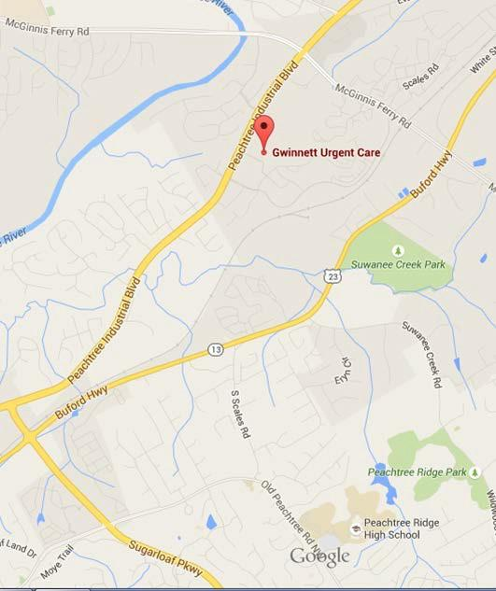
Directions
Two miles north of Sugarloaf Parkway. Just past the Fresh Market Or
Turn left at the first red light (half a mile) south of McGinnis Ferry Rd.

www.GwinnettUrgentCare.com

